

22 Club

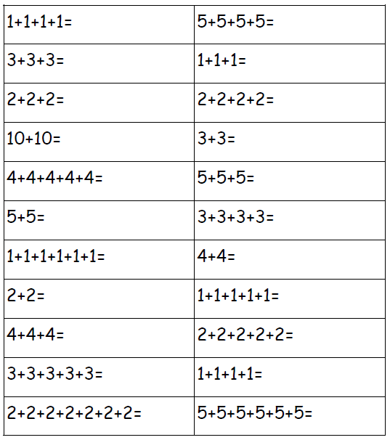Name:___________________ Date:________