

33 Club

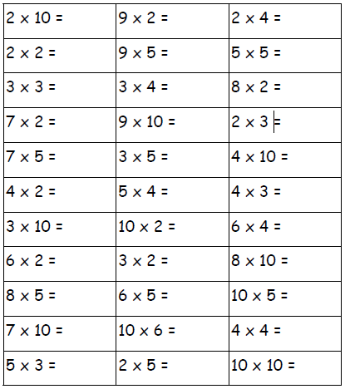Name:______________ Date:________