

55 Club

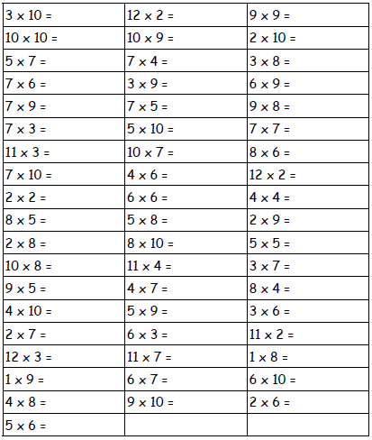Name:___________________ Date:________