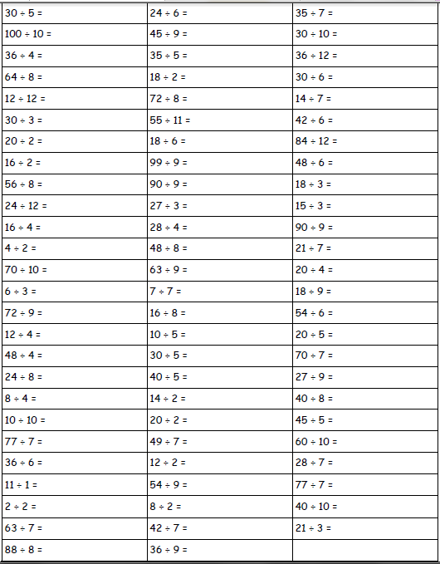

Name:_________________ Date:________

77 Club