I can’t believe we are at the end of the year already! Where has the time gone? Although this year has been extremely different and we haven’t shared as much time with each other as we normally would I am still beyond proud of every single one of you and have thoroughly enjoyed teaching you all! Throughout the year, through lockdown especially, you have all
remained so positive and enthusiastic which has made being your
teacher an even bigger reward! I have enjoyed watching you all grow,
mature and progress with your learning, it has been a pleasure. Thank you
for working so hard and being such a wonderful class to teach in the
classroom and virtually, this is definitaly a year I will remember! Have a
wonderful summer with your families enjoying the sunshine and having lots of fun and I will see
your smiling faces very soon!

Year 2 Work Week Beginning 6th July 2020
English
Reading/Writing:
Please follow the link to the Talk 4 Writing website where you will find this week’s booklet. Work your way through the booklet during the week completing the reading tasks and associated activities.
https://www.talk4writing.com/wp-content/uploads/2020/06/Y2-Quangle-F.pdf
Useful websites you may want to access during the holidays
https://www.oxfordowl.co.uk/for-home/find-a-book/library-page/ (Various ebooks)
https://www.talk4writing.com/home-school-units/ (Talk4Writing Booklets)
https://www.pobble365.com/ (Pictures for story writing or questions associated to the picture)
https://www.bbc.co.uk/bitesize/tags/z7s22sg/year-2-and-p3-lessons
Please encourage your child to think about the following when completing any writing:
-To use end if sentence punctuation (.!?) and commas in lists.
-To use capital letters at the start of sentences and for proper nouns (names of people and places).
-To make sure letters are formed correctly and are the correct height (particularly g,q,t,y,p,l,k,h,f,b) and all letters are sitting on the line correctly.
-To use conjunctions to join sentences. (e.g but, so, because, then, when, while and or).
-To spell Common Exception Words correctly for Year 2.
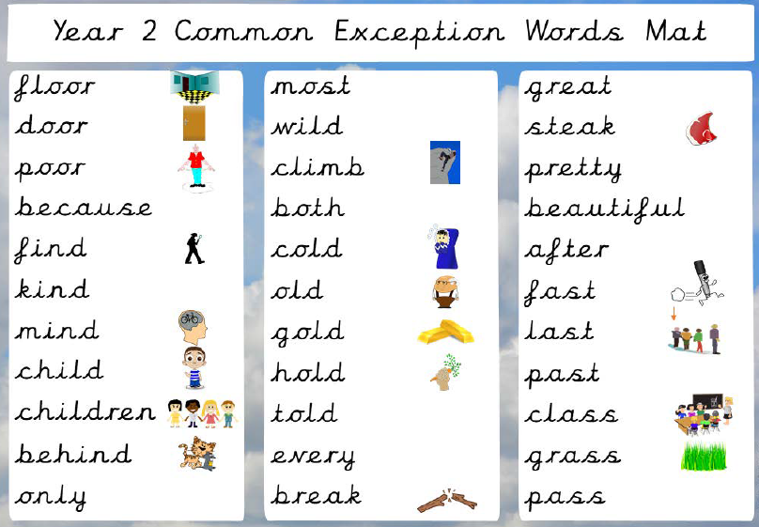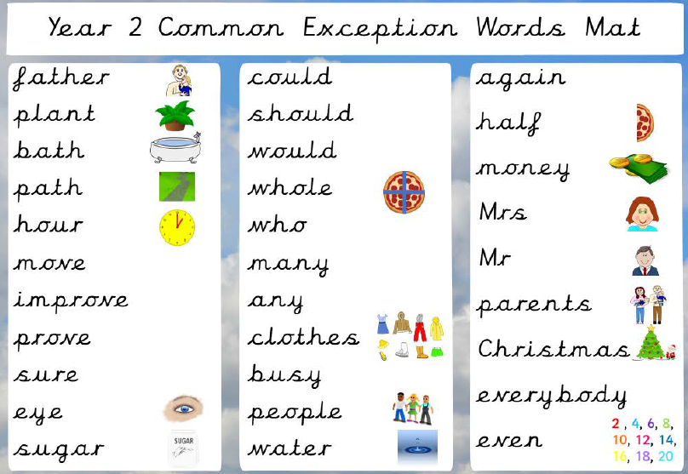

Spellings: Spelling Shed
I would like you to practise the new set of words. Adding –ing to words.
patting
humming
dropping
running
hopping
clapping
sitting
flipping
wrapping
slipping

Maths: Multiplication and Division
This week we will be completing 5 maths lessons on the National Oak Academy. For each lesson, please follow the link and complete each lesson.
https://classroom.thenational.academy/subjects-by-year/year-2/subjects/maths

To recall the 3x table using skip counting
https://classroom.thenational.academy/lessons/to-recall-the-3x-table-using-skip-counting
To use arrays for 3x and 4x table.
https://classroom.thenational.academy/lessons/to-use-arrays-for-the-3x-and-4x-tables
To know division facts for the 4x table.
https://classroom.thenational.academy/lessons/to-know-division-facts-for-the-4x-table-mm-l5

When you have completed these set tasks I would like you to think of an area you would like to practise more e.g fractions, shape. Then you can use the following websites to support your learning.

https://www.mymaths.co.uk/
https://classroom.thenational.academy/subjects-by-year/year-2/subjects/maths
https://ttrockstars.com/
https://whiterosemaths.com/homelearning/year-2/
https://masterthecurriculum.co.uk/products/?year=year-2&cat=math&subcat=addition-and-subtraction (press free resources)
https://www.hamilton-trust.org.uk/blog/learning-home-packs/
https://www.bbc.co.uk/bitesize/tags/z7s22sg/year-2-and-p3-lessons

Topic: Our Wonderful World And Me
Task 1:
We have spent a lot of time researching and learning all about the United Kingdom but this week we are going to venture further afield. I would like you to look at a globe or a map of the world and select 3 different countries maybe somewhere you have always wanted to visit or somewhere you were due to go on holiday to this summer. When you have selected 3 countries I would like you to explore and research them. What are they like? Do they have a flag? Do they have a royal family? Etc
Task 2:
Once you have finished researching and exploring the different countries compare them to where we live. This activity can be done as a writing activity in a table or as a discussion with a grown up or sibling.
Task 3:
Around the world there are many different languages that are spoken. This week I would like you to choose a different language to ours and find out the following sayings (Please share your findings on SeaSaw):
Hello
Goodbye
My name is _______.
I am ______ years old.
Task 4:
Create a poster containing lots of interesting things about you to give to your new teacher. Year 2 didn’t quite end as we would have liked but I thought it might be nice to give your new teacher a little information about you! Once you have created your poster, hold onto it until you return to school for the next academic year.

Task 5:
I know this year has been very different but I would love to hear your favourite parts/memories of year 2! I would like you to write about your favourite memory of year 2 or draw a picture to show your favourite part. Please share these on SeaSaw so I can see all of your favourite memories.

