While school is closed, children are encouraged to spend extra time learning times tables on Times Tables Rockstars, reading at home and learning spellings on Spelling Shed. Elsewhere on our website are links to other free resources to use with children when learning at home.

Below is our final week of home learning! Thank you for all the fantastic work you completed last week. Make sure you all have a great summer holiday and I will look forward to seeing you all when we return to school. Thank you again for being AWESOME and working so hard at home over the last few months. I am very proud of you all.

Year 3 Work (Week beginning 6.7.20):

English
Reading and Writing:
Serial Mash (found on the homescreen of Purple Mash)
- Select ‘Emeralds’ then ‘Pirate Family Smith’
- Read Chapter 1 Complete the online ‘multi choice questions’ (these are set as a 2Do). Complete the ‘open ended questions’ in your exercise book.
- Read Chapter 2 Complete the online ‘multi choice questions’ (these are set as a 2Do). Complete the ‘open ended questions’ in your exercise book.
- Read Chapter 3 Complete the online ‘multi choice questions’ (these are set as a 2Do). Complete the ‘open ended questions’ in your exercise book.
- Read Chapter 4 Complete the online ‘multi choice questions’ (these are set as a 2Do). Complete the ‘open ended questions’ in your exercise book.
- Read Chapter 5 Complete the online ‘multi choice questions’ (these are set as a 2Do). Complete the ‘open ended questions’ in your exercise book.
- Read Chapter 6 Complete the online ‘multi choice questions’ (these are set as a 2Do). Complete the ‘open ended questions’ in your exercise book.

Choose a task (or 2!) from the selection below to complete this week. I have set all of them as a 2Do to make it easier for you to find them. You can also complete the tasks in your exercise book. Remember to use the Think Box to help you.
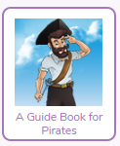
Bo is keen to become a better pirate. Create a guide book that would be helpful for beginner pirates like Bo.

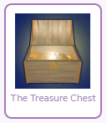
Imagine you have discovered an unopened treasure chest. Write about how you managed to open it and what you found inside. How did the contents of the treasure chest make you feel? Did it change your life for the better, or put you in danger?
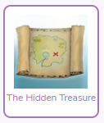
Imagine you have hidden some treasure in a secret location. You want your pirate friends to find the treasure. Write some detailed instructions to help them find your secret stash.

Spellings:
Your new list is on Spelling Shed. This week we are continuing to spell homophones. These are words which sound the same as each other but have a different spelling and meaning. For example, see and sea.

Maths
Oak Academy Maths:
This week we are looking at scales and mass.

- Use the links below.
Lesson 1 (To read a scale)
https://classroom.thenational.academy/lessons/measure-to-read-a-scale
Lesson 2 (To read mass on a scale)
https://classroom.thenational.academy/lessons/measure-to-read-mass-on-a-scale
Lesson (Ordering mass)
https://classroom.thenational.academy/lessons/ordering-mass

- For each lesson, complete the quizzes, watch the video clip and complete as much of each activity as you can.

- Ask your grown up if you can weigh a selection of objects. This will help you to practise reading a scale unless your weighing scales are digital like mine! You could then order the objects from heaviest to lightest. You could also combine weighing and cooking to make something delicious for your family!

MyMaths:
Log in to MyMaths and complete the lesson and homework for each task set. I would like you to work through the lesson because it covers more learning than the small number of questions in the homework task and there are activities and games to complete as well. This week, we are looking at using our times tables to answer scaling problems.

Other Subjects

Science and Topic: Who Put the Great in Britain?
- Can you research a famous scientist? You may want to choose a British scientist to link to our topic. Use the website below as a starting point.
https://www.dkfindout.com/uk/science/famous-scientists/
What is their name?
What are they famous for?
What else can you find out about them?
You can choose to present what you have learnt in any way you like in either your exercise book or on SeeSaw. You could create a fact file (there are templates on Purple Mash), a poster or even give a talk.

- The British countryside is home to a huge variety of plants and animals. Challenge your family and friends to a nature treasure hunt using the sheet on the next page.

Nature Hunt
Tick each box when you have found the item.
Score 2 points for each different item.

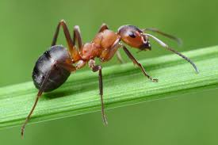 | 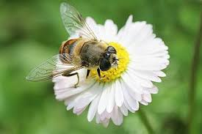 | 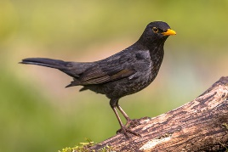 | 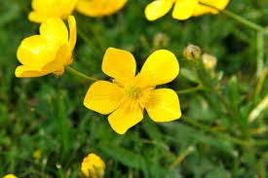 | 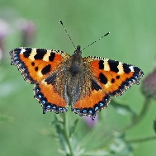
ant | bee visiting a flower | bird | buttercup | butterfly

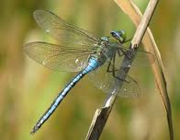 | 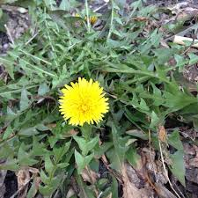 | 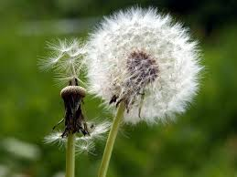 |  | 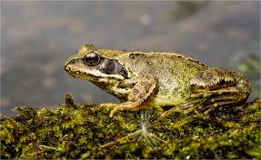
damselfly or dragonfly | dandelion | dandelion seed head | feather | frog or toad

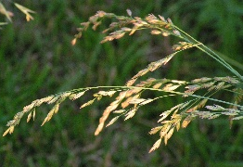 | 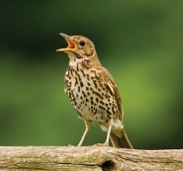 | 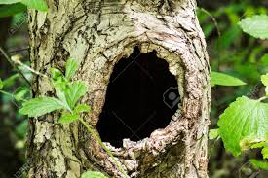 | 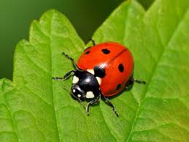 | 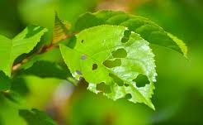
grass seed heads | hear a bird singing | hollow trunk or branch | ladybird | leaf eaten by insect

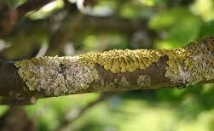 | 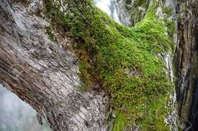 | 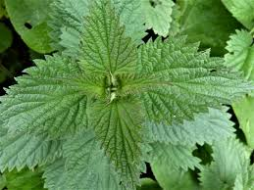 | 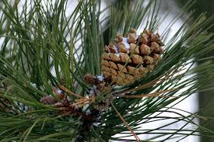 | 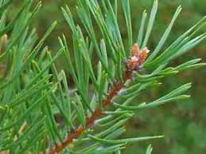
lichen | moss | nettle | pine  cone | pine  needles

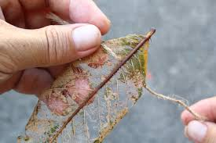 | 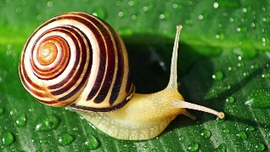 | 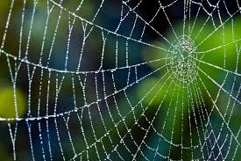 | 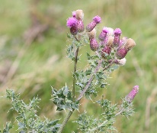 | 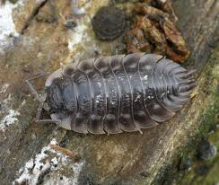
skeleton  leaf | snail | spiderweb | thistle | woodlouse

My Score: _______

Art: Making A Treasure Map

In English, we have been reading a story about pirates. Your task this week is to make a treasure map. Follow the steps below to help you and look at the photos for ideas.
- Get your piece of paper and scrunch it up.
- Tear the edges.
- Ask a grown up if you can paint the paper with cold tea or coffee.
- Leave it to dry.
- Plan, then draw your treasure map.
- Roll the paper into a tube so it looks like a scroll and fasten it with string.
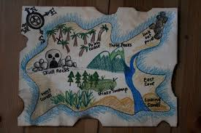
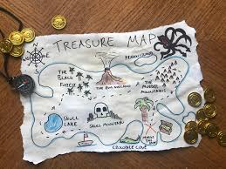
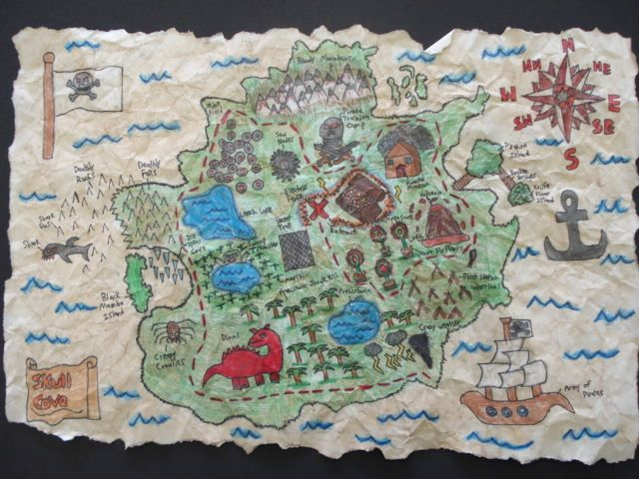

Some Ideas For If You Have Any Spare Time Over The Holidays!

Smile Challenge: Draw a HUGE smiling face then write down all the things that make you smile and laugh.

Dance Challenge: Invent a happy dance!

Selfie Challenge: Draw yourself or ‘take a selfie’ then write down 5 things you like about yourself.

Art Challenge: Write your first name in big or bubble writing and decorate it.

Lego Challenge: Build a Lego model using exactly 50 bricks.

Camera Happy: Take a photo on the following themes:
close-up, nature, colour, water, clouds, patterns, from a low angle, in the mirror, funny face, in my room

Music Madness: Find 3 songs that make you feel happy and enjoy listening to them!

